To meet the delegates of the Indian Military Heritage Festival 2026
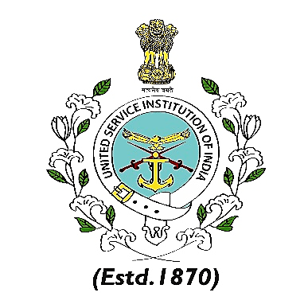
The Director General, United Service Institution of India
cordially invites

Maj Gen & Mrs Ian Cardozo
to Dinner
on Friday 30 October 2026 at 1915 hrs
at the USI of India, Rao Tula Ram Marg, Vasant Vihar, New Delhi 110057

RSVP: events@usiofindia.org
Ph no: +91-11-20862327 Dress Code: Open Collar

